**Reinforcement learning 101**

Reinforcement learning (RL) is a form of machine learning whereby an agent takes actions in an environment to maximize a given objective (a reward) over this sequence of steps. Unlike more traditional supervised learning techniques, every data point is not labelled and the agent only has access to "sparse" rewards.

While the [history of RL](http://www.incompleteideas.net/book/ebook/node12.html) can be dated back to the 1950s and there are a lot of RL algorithms out there, 2 easy to implement yet powerful deep RL algorithms have a lot of attractions recently: deep Q-network (DQN) and deep deterministic policy gradient (DDPG). We briefly introduce the algorithms and variants based on them in this section.

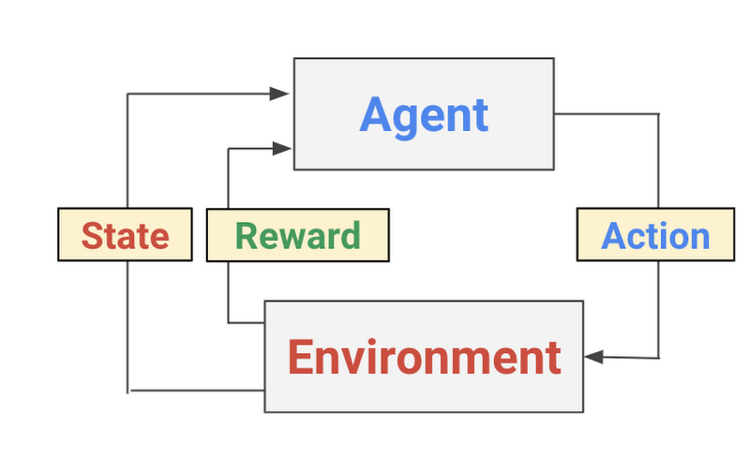

*A conceptual process diagram of the Reinforcement Learning problem*

The Deep Q-network (DQN) was introduced by Google Deepmind's group in [this Nature paper](https://storage.googleapis.com/deepmind-media/dqn/DQNNaturePaper.pdf) in 2015. Encouraged by the success of deep learning in the field of image recognition, the authors incorporated deep neural networks into Q-Learning and tested their algorithm in the [Atari Game Engine Simulator](https://gym.openai.com/envs/#atari), in which the dimension of the observation space is very large.

The deep neural network acts as a function approximator that predicts the output Q-values, or the desirability of taking an action, given a certain input state. Accordingly, DQN is a value-based method: in the training algorithm DQN updates Q-values according to Bellman's equation, and to avoid the difficulty of fitting a moving target, it employs a second deep neural network that serves as an estimation of target values.

On a more practical level, the following model highlights the source files, the shell command, and the endpoint to get an RL job running on GCP:

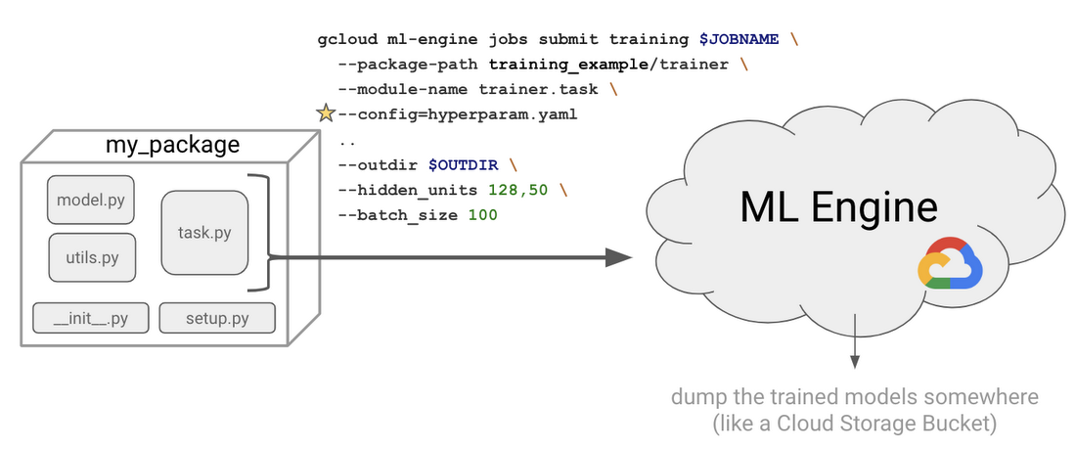

**Create an AI Platform Notebook**

All the required files that you need for this lab can be found in this [repository](https://github.com/GoogleCloudPlatform/training-data-analyst/pull/745). You will create an AI platform tensorflow notebook to run all these commands.

From the left-hand navigation menu, select **AI Platform** > **Notebooks**. Then from the top-hand menu, select **+ New Instance** > **TensorFlow 2.x** > **Without GPUs:**

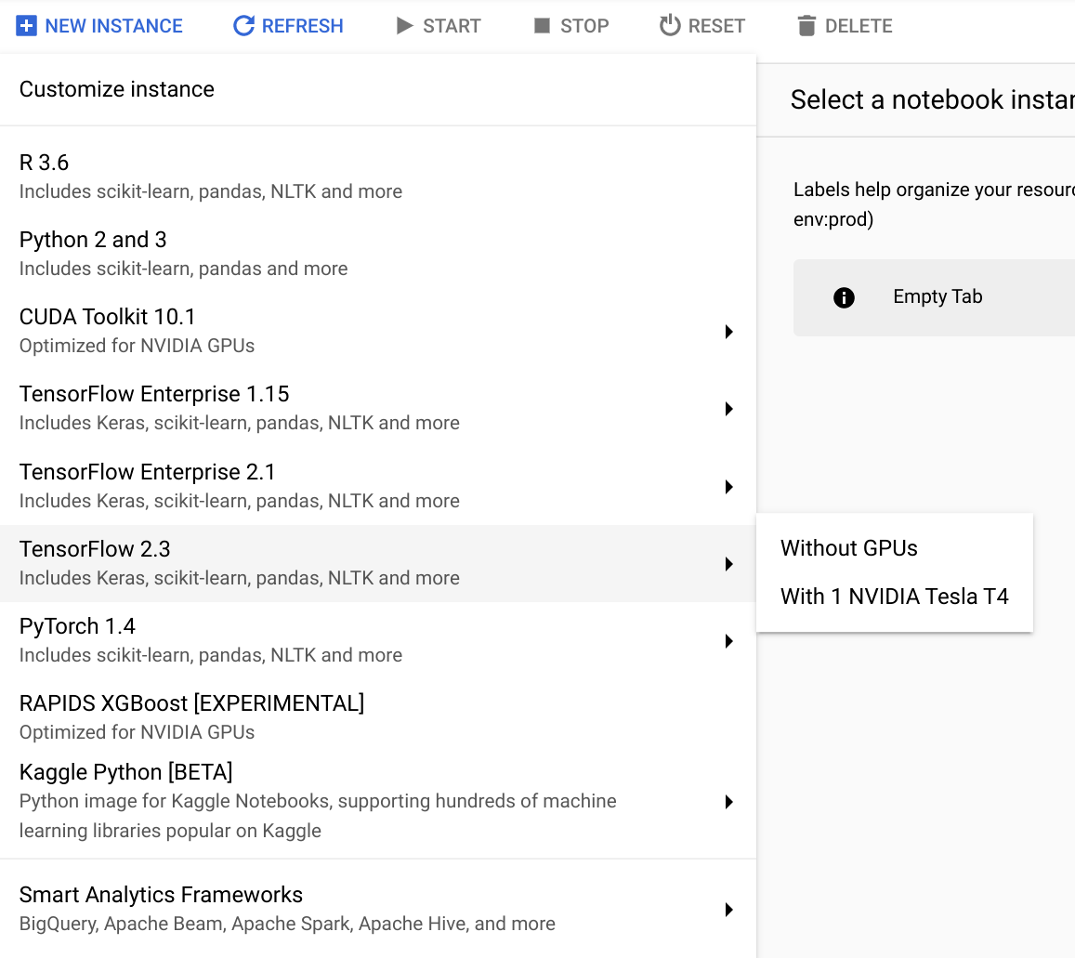

Then click **Create**. It will take a couple of minutes to provision your AI Platform Notebook. Refresh the page occasionally. Once the notebook has been built, click the **OPEN JUPYTERLAB** button:

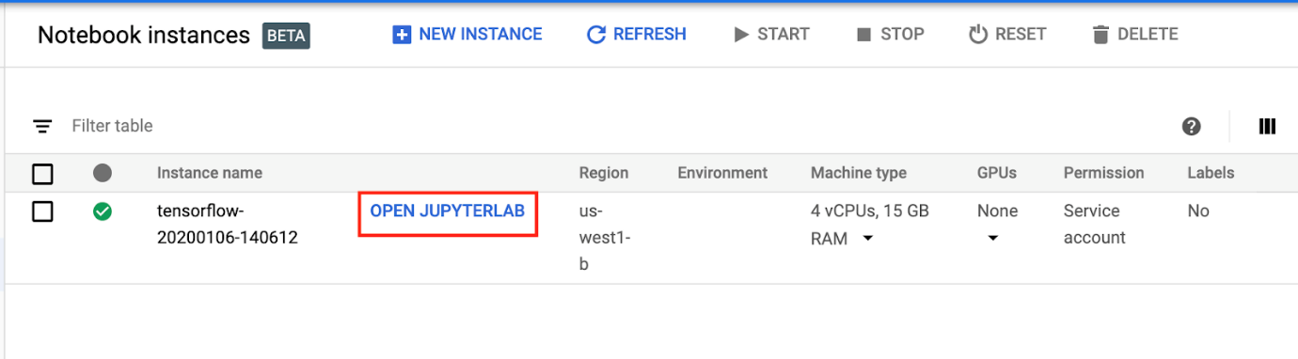

This will open a new tab with your Jupyterlab loaded.

Click *Check my progress* to verify the objective.

Create an AI Platform Notebook

Check my progress

**Clone the sample code**

Click on the **Terminal** icon. This will give you a temporary shell to enter commands. Enter in the following command to clone the sample repo from the training data analyst repository:

git clone https://github.com/GoogleCloudPlatform/training-data-analyst.git

Wait for this command to propagate. Then from the left-hand menu, select **training-data-analyst**> **quests**> **rl** > **early_rl** > **early_rl.ipynb**. This will open a new tab.

Click *Check my progress* to verify the objective.

Clone the sample code

Check my progress

**Run through the notebook**

Your new tab should look similar to the following:

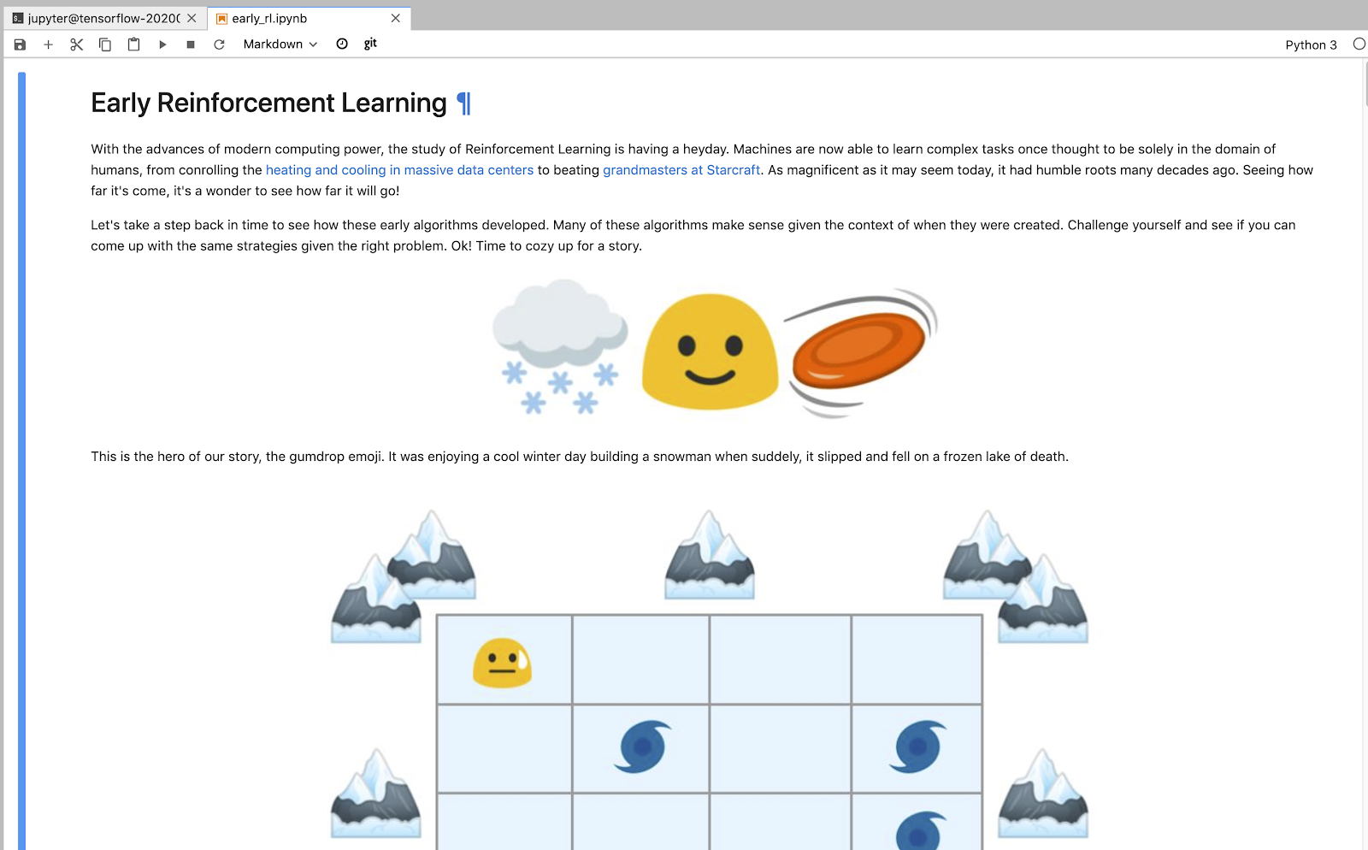

Read through the following notebook and run all code blocks with **Shift + Enter**.

Return here after you have completed the instructions in the notebook.

**Congratulations!**

In this lab you learned the basic principles of reinforcement learning (RL). After creating a Jupyterlab instance, you cloned a sample repository and ran through a notebook where you received hands-on practice with the fundamentals of reinforcement learning. You are now ready to take more labs in this series.

Finish Your Quest

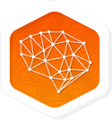

This self-paced lab is part of the Qwiklabs Quest [Baseline: Data, ML, AI](https://google.qwiklabs.com/quests/34). A Quest is a series of related labs that form a learning path. Completing this Quest earns you the badge above, to recognize your achievement. You can make your badge (or badges) public and link to them in your online resume or social media account. [Enroll in this Quest](https://google.qwiklabs.com/quests/34/enroll) and get immediate completion credit if you've taken this lab.